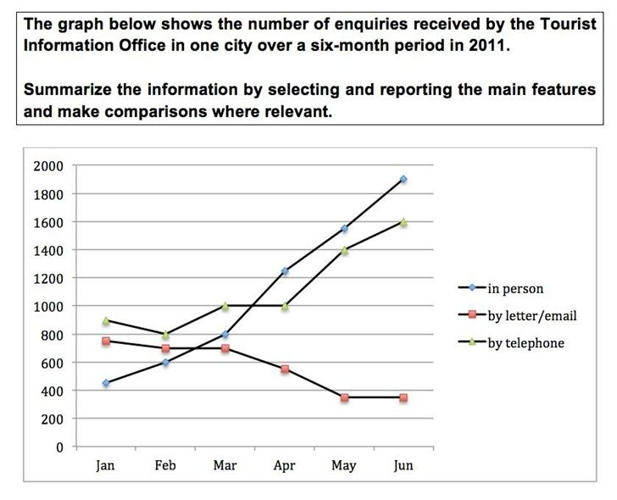

The given infographic illustrates the quantity of requests which were accepted from the public of unknown city to Tourist Information Office via online (email), telephone and the human factor.

Overall, it is apparent that there was a sharp upward trend in the number of enquiries by people and by telephone during the six month of the year 2011; however other types of the enquiries namely lettering and emailing saw a significant reduction from January to June.

As regards the first three-month of 2011, requests by telephone and human factor quantities stood at nearly 900 and roughly 420 respectively while queries by letter/email was just less than by telephone. It is considered that there were no any important fluctuations apart from the number of the telephone users until middle of the March.

When it comes to next three months, as predicted, the human factor in querying to Tourist Information Office continued to rise dramatically until reaching about 1900 requests among with the number of telephone users accounted less than human factor by approximately 350.
In comparison, the number of usage of the letters and emails by unknown city residents experienced considerable decrease between the months the March and June.

